CHAPTER 2—SCIENTIFIC METHODS IN BIOLOGY

TRUE/FALSE

1. Arthropods do not have a well-developed excretory system consisting of nephridia.

ANS: T DIF: B OBJ: 2-1

2. The medulla oblongata of the brain produces an antidiuretic hormone (ADH) that stimulates the reabsorption of water.

ANS: F OBJ: 2-1 DIF: B

MODIFIED TRUE/FALSE

1. The liter is a metric unit of volume. ____________

ANS: T DIF: B OBJ: 2-1

2. For ease of understanding, scientists report measurements using the English system. __________

ANS: F
SI (or metric)

DIF: B OBJ: 2-1

MULTIPLE CHOICE

1. The study of standards for what is right and what is wrong is called _____.
a. pure science
b. applied science
c. ethics
d. technology

ANS: C DIF: B OBJ: 2-4

2. Technology has allowed humans to produce more food and reduce the chance of starvation by individuals in some countries. How has this advance created additional problems?
a. The technology has allowed populations to continue to grow, creating the need for additional food.
b. The technology caused salts to be deposited in soils.
c. The technology caused the false belief that the problem was solved forever.
d! All of these.

ANS: A DIF: B OBJ: 2-4

NARRBEGIN: Table 2-2
Table 2-2

Day | Number of Plants  Flowering
2 | 6
4 | 12
6 | 18
8 | 22
10 | 8

NARREND

3. Students of a biology class ran an experiment on a type of flowering plant. Their goal was to find the optimal time in the plant's life for flowering. What time period will provide the most flowering plants? Use Table 2-2 to determine your answer.
a. 5-6 days
b. 6-7 days
c. 7-8 days
d. 8-9 days

ANS: C DIF: A OBJ: 2-1 NAR: Table 2-2

COMPLETION

1. The _______________ consists of evaporation, precipitation, transpiration, runoff, and respiration.

ANS: water cycle DIF: B OBJ: 3-6

2. Omnivores, carnivores, herbivores, scavengers, and decomposers are all _______________.

ANS: consumers DIF: B OBJ: 3-5

3. Organism, population, and community make up the _______________.

ANS: ecosystem DIF: B OBJ: 3-2

MATCHING

Match each item with the correct statement below.
a. mutualism h. food web
b. biosphere i. food chain
c. ecology j. commensalism
d. community k. scavenger
e. decomposer l. heterotroph
f. parasitism m. trophic level
g. habitat n. autotroph

1. study of how living things relate to each other and to their environment
2. relationship between organisms in which both organisms benefit
3. network of interconnected food chains
4. relationship between organisms in which one organism benefits and the other is neither harmed nor benefited
5. layer of Earth that supports life
6. feeds on dead organisms
7. simple model for showing how matter and energy move through an ecosystem
8. group formed by several populations
9. manufactures food using energy from the sun or from chemical compounds
10. relationship between organisms in which one organism benefits at the expense of another
11. place where an organism spends its life
12. step in the passage of energy and matter through an ecosystem
13. obtains energy and nutrients from autotrophs
14. breaks down dead organisms

1. ANS: C DIF: B OBJ: 3-1
2. ANS: A DIF: B OBJ: 3-4
3. ANS: H DIF: B OBJ: 3-5
4. ANS: J DIF: B OBJ: 3-4
5. ANS: B DIF: B OBJ: 3-1
6. ANS: K DIF: B OBJ: 3-5
7. ANS: I DIF: B OBJ: 3-5
8. ANS: D DIF: B OBJ: 3-2
9. ANS: N DIF: B OBJ: 3-5
10. ANS: F DIF: B OBJ: 3-4
11. ANS: G DIF: B OBJ: 3-3
12. ANS: M DIF: B OBJ: 3-5
13. ANS: L DIF: B OBJ: 3-5
14. ANS: E DIF: B OBJ: 3-3

Write the letter of the safety symbol in Figure 2-1 to the left of its description.
15. Substance is flammable or combustible; using an open flame could cause a fire or an explosion.
16. Chemicals or reactions between chemicals could produce dangerous fumes.
17. Be careful around open flames.
18. Substance is poisonous.
19. Misuse or mixing of chemicals could cause an explosion.
20. Handling of hot objects could cause burns.

15. ANS: D DIF: B OBJ: 2-1
16. ANS: C DIF: B OBJ: 2-1
17. ANS: B DIF: B OBJ: 2-1
18. ANS: E DIF: B OBJ: 2-1
19. ANS: A DIF: B OBJ: 2-1
20. ANS: F DIF: B OBJ: 2-1

SHORT ANSWER

1. Compare and contrast inductive reasoning and deductive reasoning.

ANS:
In inductive reasoning, a particular set of facts is used as a basis to formulate a general rule; in deductive reasoning, a general rule is applied to a specific case.

DIF: A OBJ: 2-1

NARRBEGIN: Steps 2-1
A student noticed that when a dog is cut, the dog periodically licks its wounds. Usually after a few days, the wound begins to heal without ever showing signs of infection. The following steps outline the student's line of reasoning:
A. I wonder why the dog's wound doesn't become infected.
B. The dog's saliva must prevent the growth of infection-causing bacteria.
C. I'll obtain a bacterial culture and grow the same kind of bacteria in two identical culture dishes. Once the bacteria start growing, I'll add dog saliva to only one of the dishes and leave the other alone. I'll cover both dishes. Then I'll observe what happens each day for a week.
D. Even after adding the dog saliva to one of the dishes, the bacteria continued to grow in both dishes over the course of the week. However, the bacteria in the treated dish grew more slowly than the bacteria in the untreated dish.
E. I think I'll try something else. I'll start with two identical culture dishes, as before, and use the same kind of bacteria in each dish, but this time I'll treat one dish with dog saliva before I add the bacteria. I'll observe what happens each day for a week.
NARREND

2. Why might the experimental design in step E be a better test of the student's hypothesis than the design used in step C?

ANS:
Answers may vary. The hypothesis is framed around the idea that the dog's saliva prevents initial bacterial growth, so testing to see whether bacteria begin to grow in the presence of dog saliva might be a more accurate test of the hypothesis than testing to see if the saliva destroys or slows down the growth of bacterial colonies that are already established.

DIF: A OBJ: 2-1 NAR: Steps 2-1

PROBLEM

NARRBEGIN: Table 2-1
One hundred pregnant women and their developing fetuses were monitored over the course of pregnancy in a study designed to compare the average weight gain of a woman during pregnancy with the average weight gain of the developing fetus. This is shown in Table 2-1. (Note that the weight gain of the developing fetus is its actual weight.)

Table 2-1

Week of  pregnancy | Weight gain of  mother (kg) | Weight gain of  fetus (kg)
8 | 1.5 | not measurable
12 | 1.8 | 0.25
16 | 3.0 | 0.25
20 | 4.0 | 0.50
24 | 5.5 | 0.75
28 | 8.0 | 1.25
32 | 10.0 | 2.00
36 | 13.0 | 2.25
40 | 15.0 | 3.00

NARREND

1. Using Table 2-1, how does the mother's rate of weight gain compare with the rate of weight gain of the developing fetus?

ANS:
The mother gains weight much more rapidly than the developing fetus.

DIF: A OBJ: 2-3 NAR: Table 2-1

2. Graph the data for the mother and the fetus on the grid in Figure 2-2. Decide on a method to distinguish the sets of data. Be sure to label each graph.

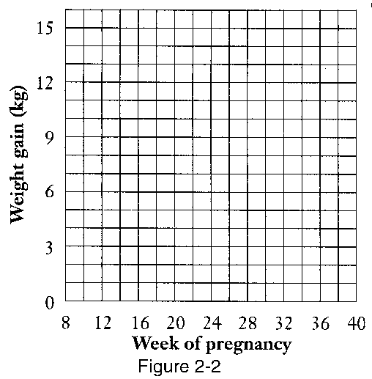

ANS:
See Solution 2-1 answer art.

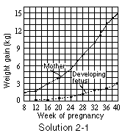

DIF: A OBJ: 2-3 NAR: Table 2-1

